Project design phase-2
Technology Stack

Date
Team Id | NM2025TMID02994
Project name | LEASE MANAGEMENT
Maximum Mark

Order processing during pandemics for offline mode:

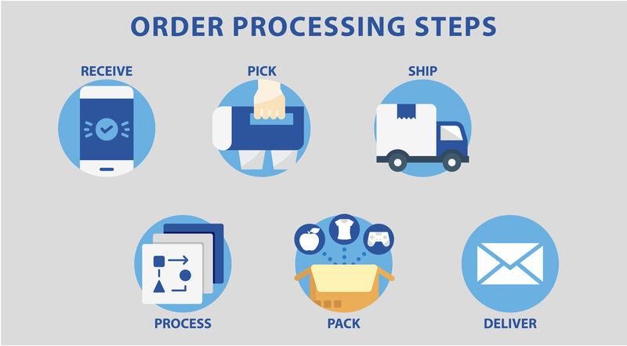

Component & Technology:

Category | Technology & Concepts | Rationale
Deployment Model | Cloud-Native / SaaS (AWS, Azure, GCP) | Provides high scalability to handle thousands of leases, ensures high availability (uptime), and simplifies maintenance/updates for compliance changes.
Core Database | Relational Databases (SQL Server, PostgreSQL, Oracle) | Necessary for the complex, highly relational data model that links assets, contracts, financial schedules, and parties in an auditable manner.
User Interface (UI) | Modern Web Frameworks (React, Angular, Vue.js) | Delivers an intuitive, responsive user experience with clear dashboards and complex data visualization for financial users.
Financial Logic | Dedicated Calculation Engine (Often proprietary) | Utilizes object-oriented programming (e.g., Java, C#) to execute complex, time-sensitive interest compounding and present value calculations required by IFRS 16/ASC 842 with guaranteed accuracy.
Integration | RESTful APIs, Web hooks, ETL Tools | Enables real-time or scheduled data transfer with core enterprise systems like ERP, GL, and BI tools, reducing manual effort and errors.
Data Extraction (Optional) | OCR and NLP (AI/ML) | Used to automatically read and abstract key terms (dates, payments, options) from PDF or scanned lease documents, accelerating the data entry process.
Security | TLS/SSL Encryption, SSO (SAML/OAuth), MFA, RBAC | Ensures financial data is secure and protected at all times, meeting stringent enterprise and regulatory requirements (e.g., SOC 1/2 compliance).

Application Characteristic:

Category | Characteristic | Description & Rationale
Financial & Compliance | High Accuracy & Precision | The system must execute complex interest, present value, and amortization calculations with high precision to ensure balance sheet accuracy and regulatory adherence (IFRS 16/ASC 842).
 | Comprehensive Auditability | Maintains a time-stamped, immutable audit trail of all data changes, calculations, and financial postings to satisfy external audit requirements (SOC 1/2).
 | Configurable Compliance Engine | Must allow easy configuration for different accounting treatments (e.g., Finance vs. Operating) and quickly adapt to regulatory updates without custom coding.
 | Premeasurement Capability | Must efficiently handle Day 2 accounting by recalculating ROU assets and lease liabilities following modifications, generating new schedules.
Operational & Functional | Centralized Data Repository | Serves as the single source of truth for all contracts, financial data, and associated documents across the entire lease portfolio.
 | Workflow Automation | Provides robust tools to configure and enforce automated workflows for approvals, amendments, and option exercises, reducing manual errors.
 | Intuitive, Role-Based UI | The interface must be easy to navigate and tailored to the specific needs of different users (e.g., Lease Admins vs. Finance Accountants).
 | Effective Alerting System | Delivers timely, configurable notifications for critical dates (renewal deadlines, termination options) to prevent costly missed decisions.
Technical & System | Scalability | Must be architected to efficiently handle tens of thousands of lease records and associated financial schedules without performance degradation.
 | Integration Capability | Provides secure, robust APIs for seamless and automated data transfer with core enterprise systems like the ERP/GL and Fixed Asset register.
 | Role-Based Security (RBAC) | Implements granular access controls to protect sensitive financial and contractual data based on the user's defined role.
 | Performance | Guarantees fast response times for calculating large financial schedules and generating statutory disclosure reports.

